Alexander Baldree
04/29/26
Module 7.2 Assignment
CSD420

GitHub Link:
https://github.com/Panda-Alex21687/CSD420/tree/main/Module 7

Program library setup MAVEN:
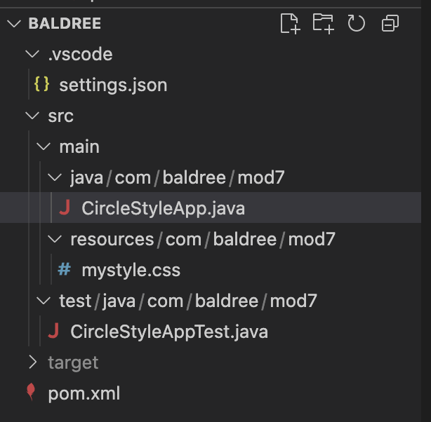

Program Build:
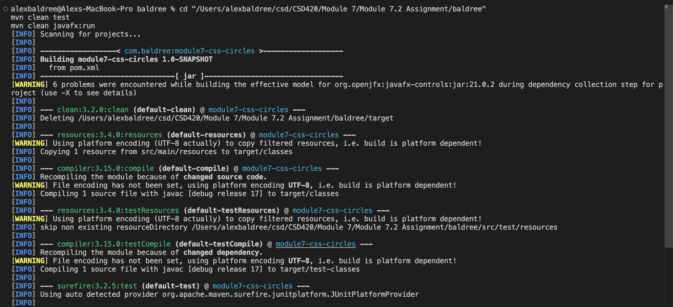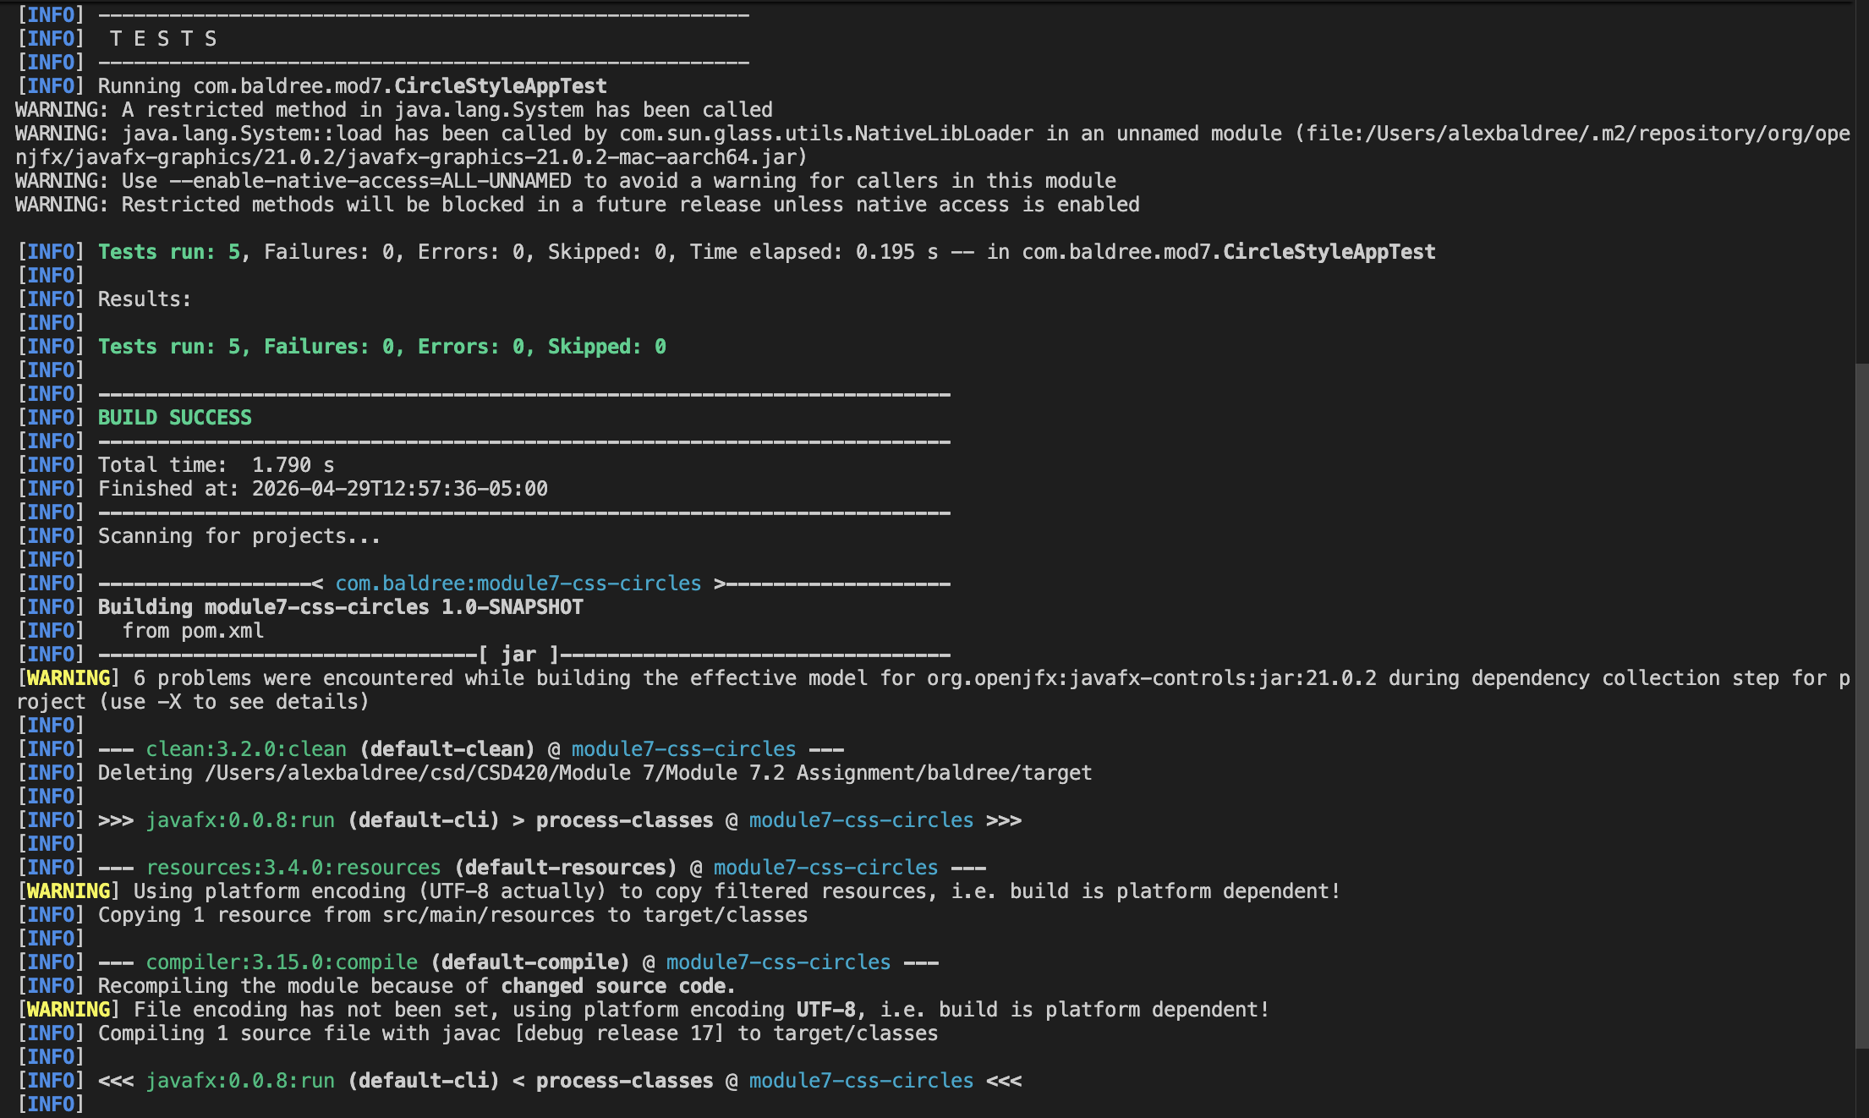

Java Version:
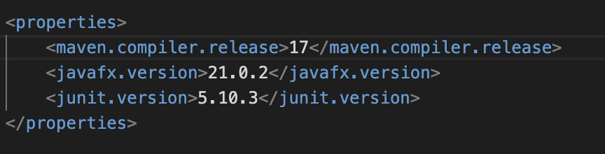
JavaFX Program Run:
